Simultaneous photometry of hundreds of objects in AstroImageJ
Two helper scripts apgen.py and aijplot.py are used to perform photometry of hundreds of objects in AstroImageJ.
The apgen.py script identifies star-like sources in a FITS image using World Coordinate System (WCS) information provided as a command-line parameter.
Run apgen.py with the -h option to display a description of the available parameters.
usage: apgen.py [-h] [--fwhm FWHM] [--n_sigma N_SIGMA] [--peakmax PEAKMAX] [--plot] filename [output]

The script takes an input FITS image (which must contain WCS) and extracts the
coordinates of the star-like sources into an output file.

positional arguments:
filename Path to the input image file
output Output file name. Default: radec_list.txt

options:
-h, --help show this help message and exit
--fwhm FWHM Full Width at Half Maximum (FWHM) in pixels (1–20).
Default: 4.0
--n_sigma N_SIGMA Threshold (3–999). Default: 5.0
--peakmax PEAKMAX Upper limit for peak pixel value (to exclude saturated
stars). Ignored if it is <= 0. Default: -1 (i.e.,
ignored)
--plot Show the image with apertures. Default: do not show)

It creates an output file containing the coordinates of these sources in a format recognizable by AstroImageJ. An example of the first few lines is shown below:
22:36:06.78, +34:00:57.3, 1, 1, 12.741
22:36:18.66, +33:38:17.8, 0, 1, 99.999
22:36:44.96, +33:39:09.6, 0, 1, 99.999
22:36:25.27, +33:38:39.4, 0, 1, 99.999
22:34:25.40, +33:35:07.1, 0, 1, 99.999
22:35:39.67, +33:37:23.3, 0, 1, 99.999
22:36:13.69, +33:38:35.3, 0, 1, 99.999
The first line was modified manually: one of the stars was selected as a reference (comparison) star. Its entry was copied to the beginning of the file (this step is not required but was done for convenience). A value of ‘1’ in the third column indicates a reference star, and the last value in the line is its magnitude. At least one comparison star must be present on the list.
To use these coordinates, load a stack of images into AstroImageJ and select the “File” → “Import apertures from RA/Dec list...” command from the menu. The list will be loaded, and the apertures will be displayed. Note that all loaded images must contain WCS information.
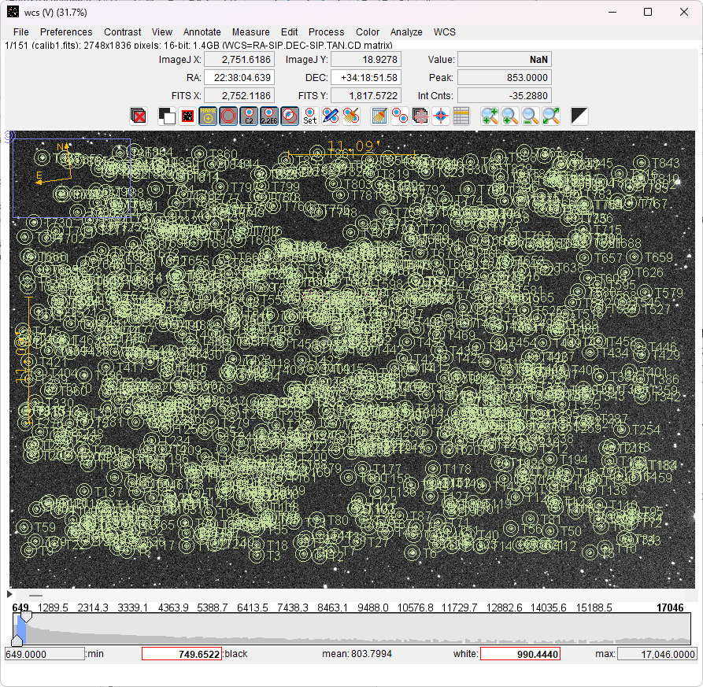
Then select the “Analyze” → “Multi-Aperture…” command. Set the aperture parameters as usual. It is recommended to use the “Fixed Apertures” mode when performing photometry with many apertures that may overlap. It is also recommended to uncheck the “Halt processing on WCS or centroid error” checkbox.
The process may take some time for a large number of frames. At the end, save the “Measurements” table to a text file (e.g., Table.tsv). The data in this file can then be visualized using the second script, aijplot.py.

usage: aijplot.py [-h] [--sat-lim SAT_LIM] [--n-sig-clip N_SIG_CLIP]
[--bin BIN]
filename [output]

The script creates an HTML file with the light curve plots

positional arguments:
filename Path to the input photometry table (AstroImageJ format
with magnitudes)
output Output file name. Default: Photometry.html

options:
-h, --help show this help message and exit
--sat-lim SAT_LIM Saturation limit. Ignored if it is <= 0. Default: -1
(i.e., ignored)
--n-sig-clip N_SIG_CLIP
N of sigmas for clipping outliers. Ignored if it is <=
0. Default: 5
--bin BIN Bin size. Ignored if it is <= 1. Default: 1

The resulting HTML file (Photometry.html) can be viewed in a web browser. It contains a vertically scrollable strip of light curve plots (see the example below).
